

FACULTY OF ELECTRONICS

COMPUTER ENGINEERING AND TELECOMMUNICATIONS DEPARTMENT

LABORATORY WORK #7

Modeling a Radio Link

Student: Mark Mikula

Teacher: Artūras Medeišis

Vilnius, 2025

Contents

Practical Part 2

Section 1: Project Setup and License Activation 2

Section 2: Interface Familiarization and Map Navigation 4

Theoretical Part 9

Fresnel Zone Analysis 9

Fade Margin Considerations 9

Link Budget Analysis 9

Conclusion 10

# Practical Part

## Section 1: Project Setup and License Activation

This lab focuses on modeling a radio link using ArcGIS and Cellular Expert. The primary goal is to plan a radiocommunication network by establishing a Microwave Point-to-Point Link between two chosen locations.

**Steps:**

* Launch Cellular Expert software
* Create a new project workspace
* Navigate to license activation menu
* Enter the Cellular Expert Core Module license key from the provided Excel file
* Verify successful license activation

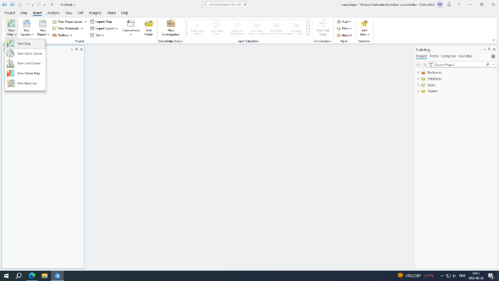

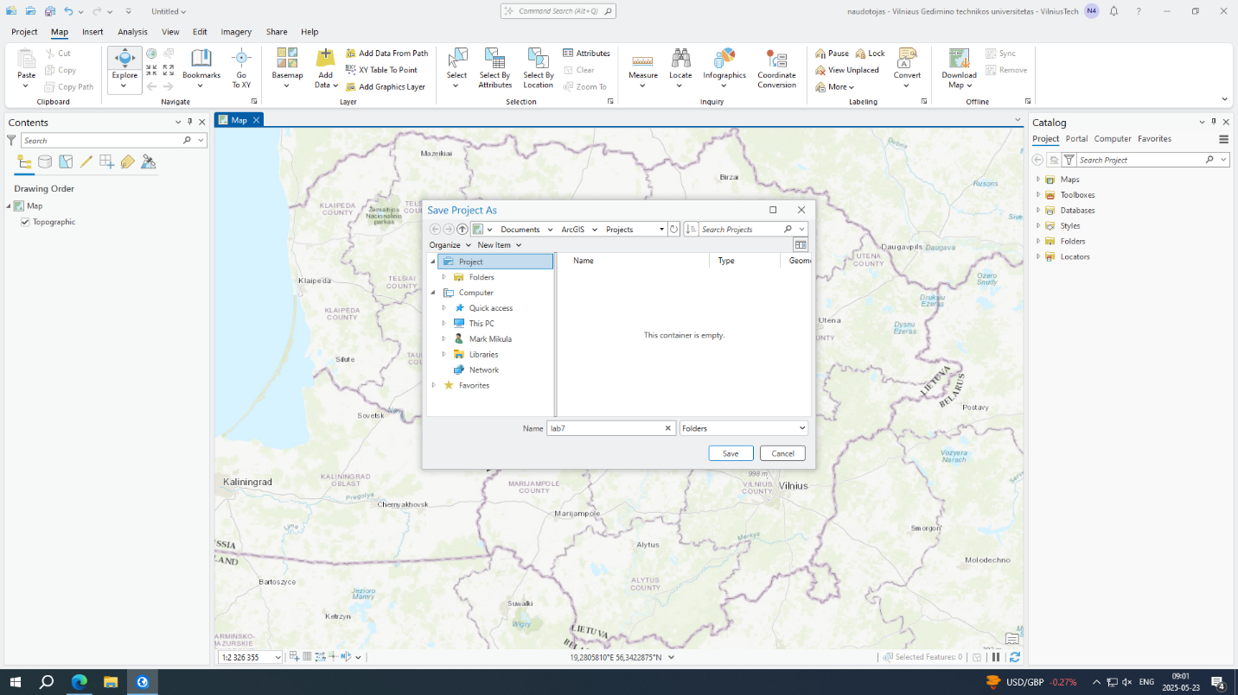 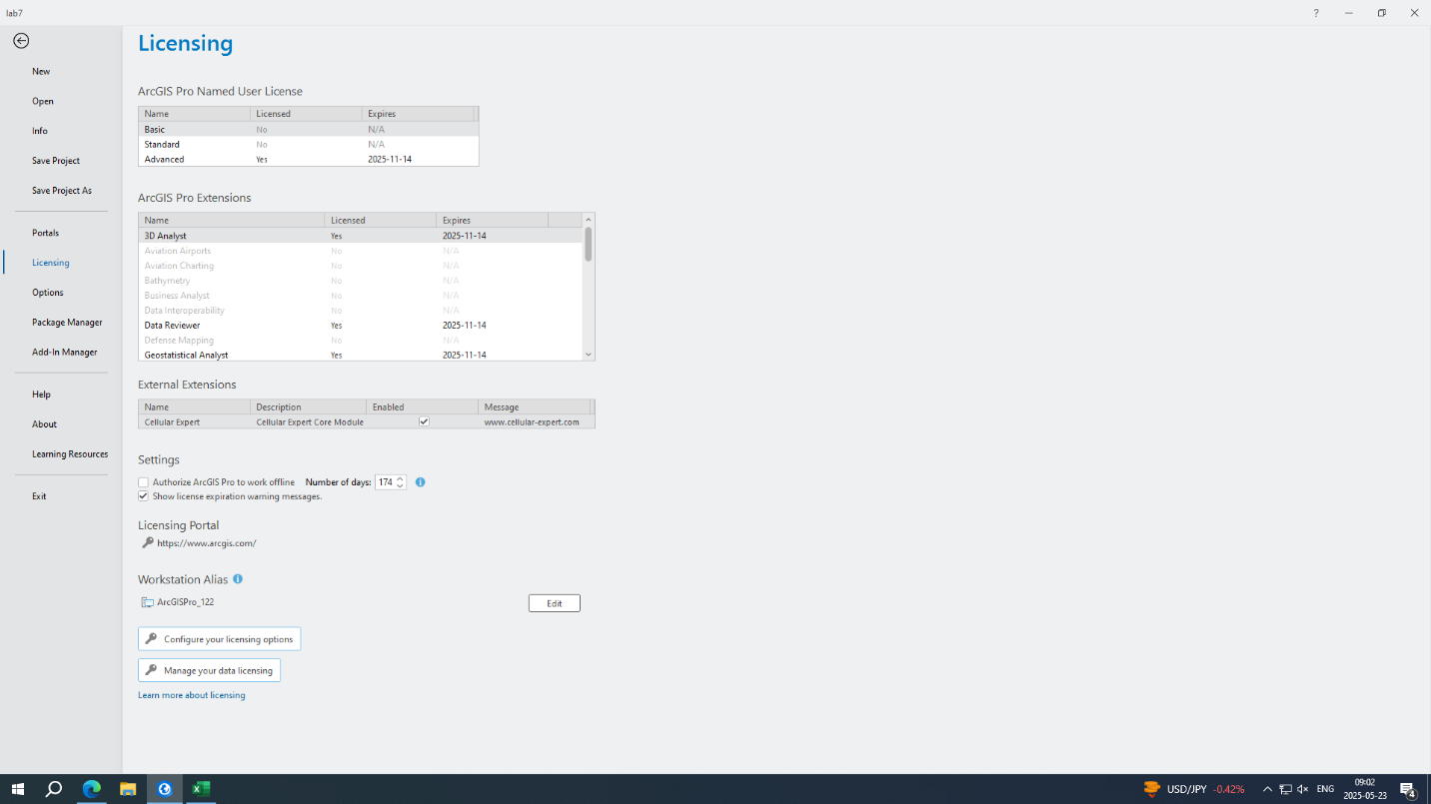

## Section 2: Interface Familiarization and Map Navigation

Steps:

Explore the main interface layout

Familiarize with map navigation controls (zoom, pan, rotate)

Identify key toolbar functions and menu options

Test basic map utilities and measurement tools

Load appropriate GIS data layers for the target area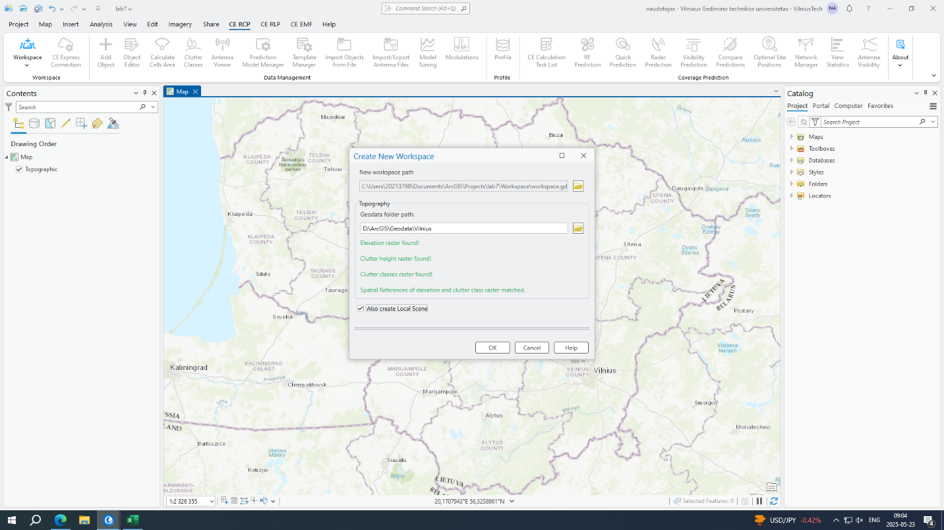 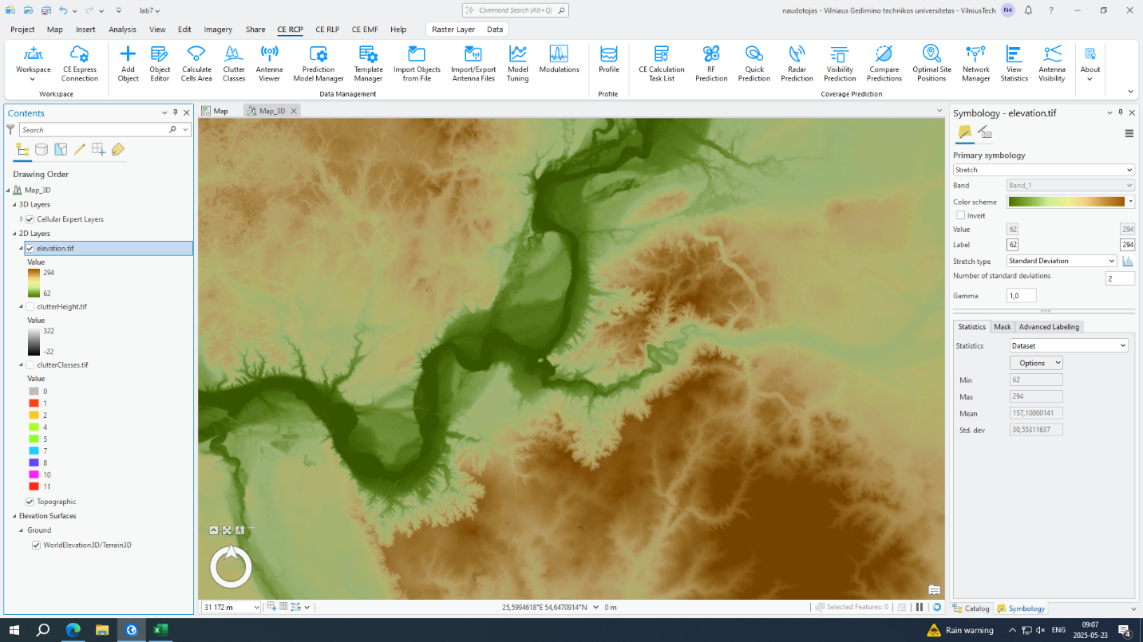 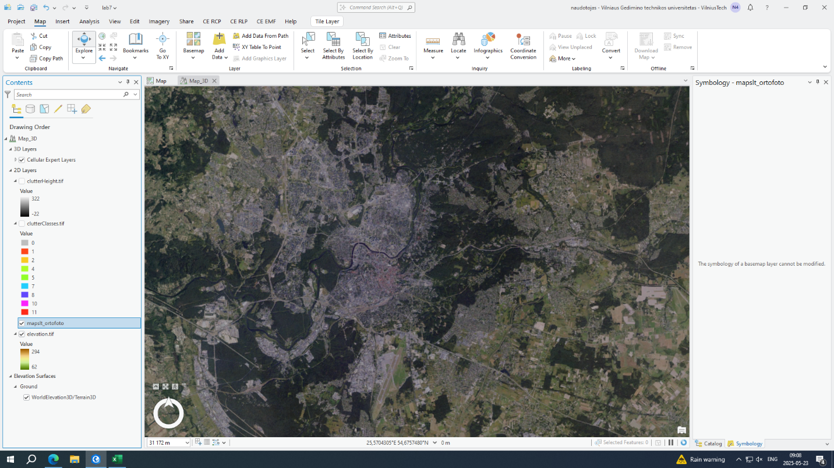

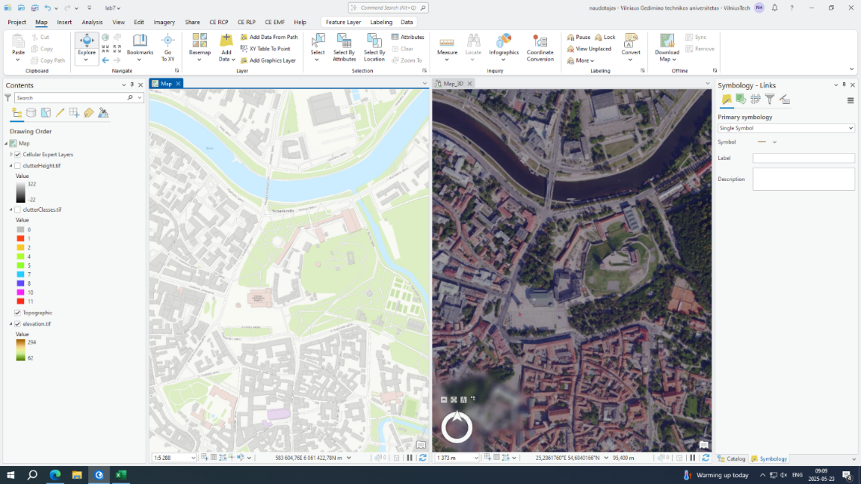 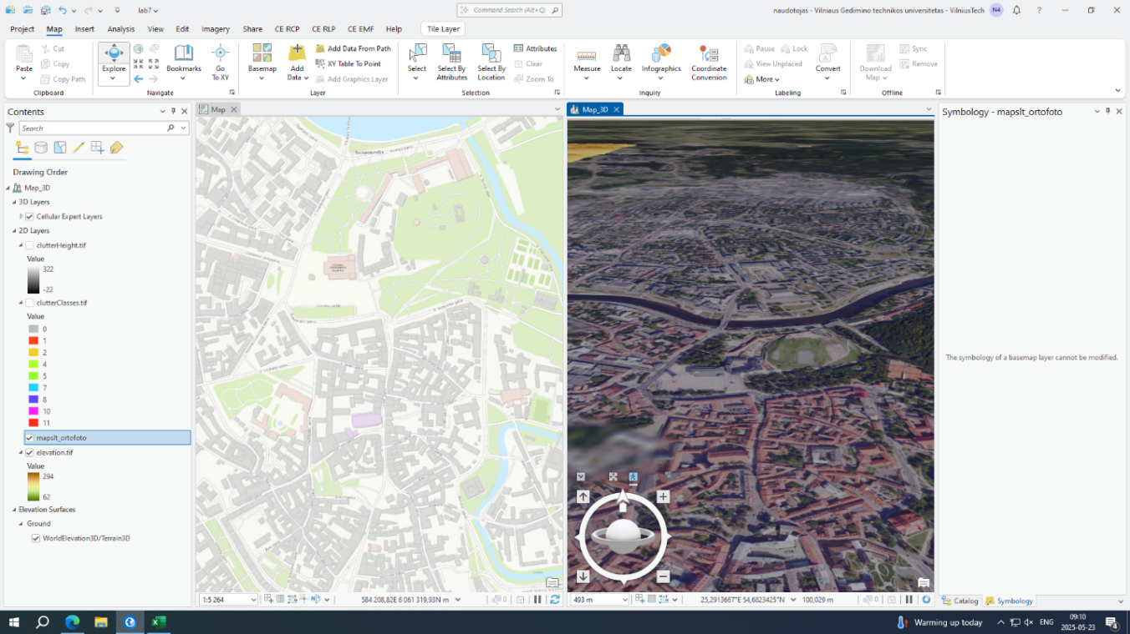 Section 3: Microwave Link Creation

**Steps:**

* Access the Microwave Point-to-Point Link creation tool
* Select the first endpoint location on the map
* Place the second endpoint at the desired destination
* Configure initial link parameters
* Set preliminary antenna specifications

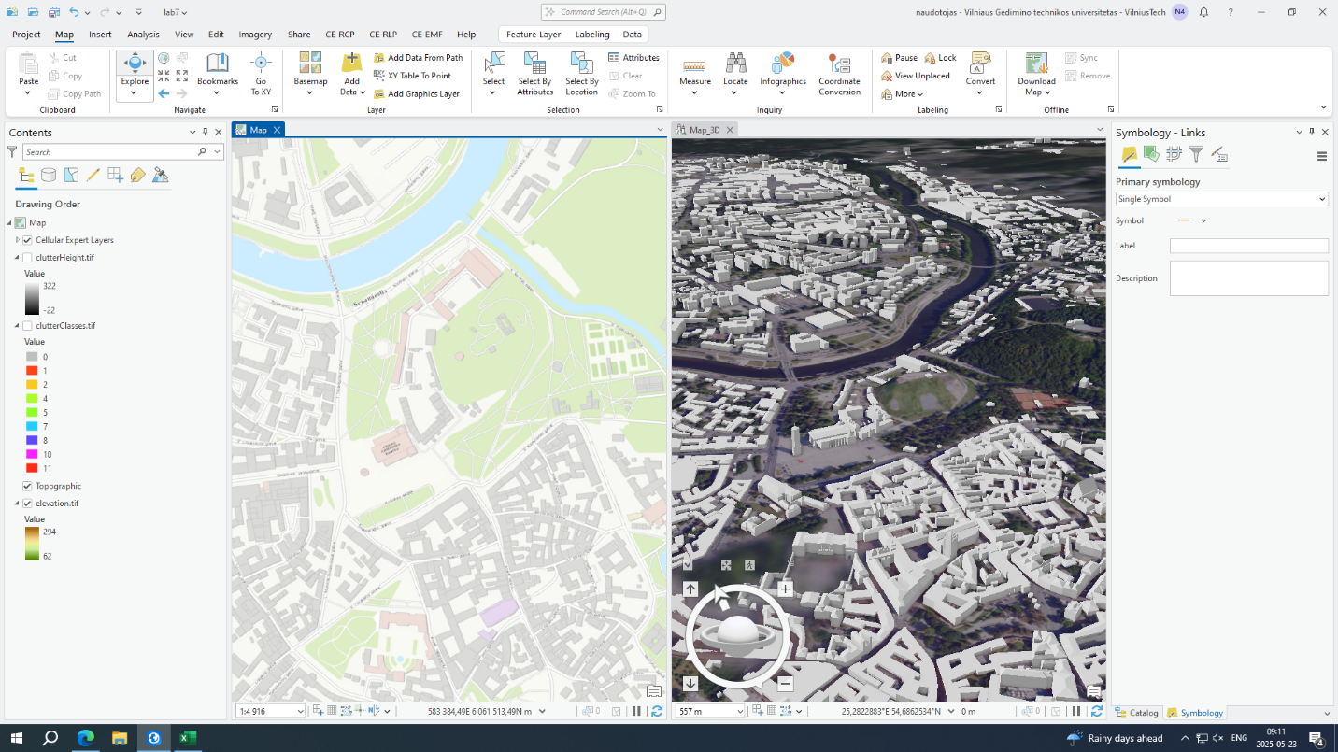 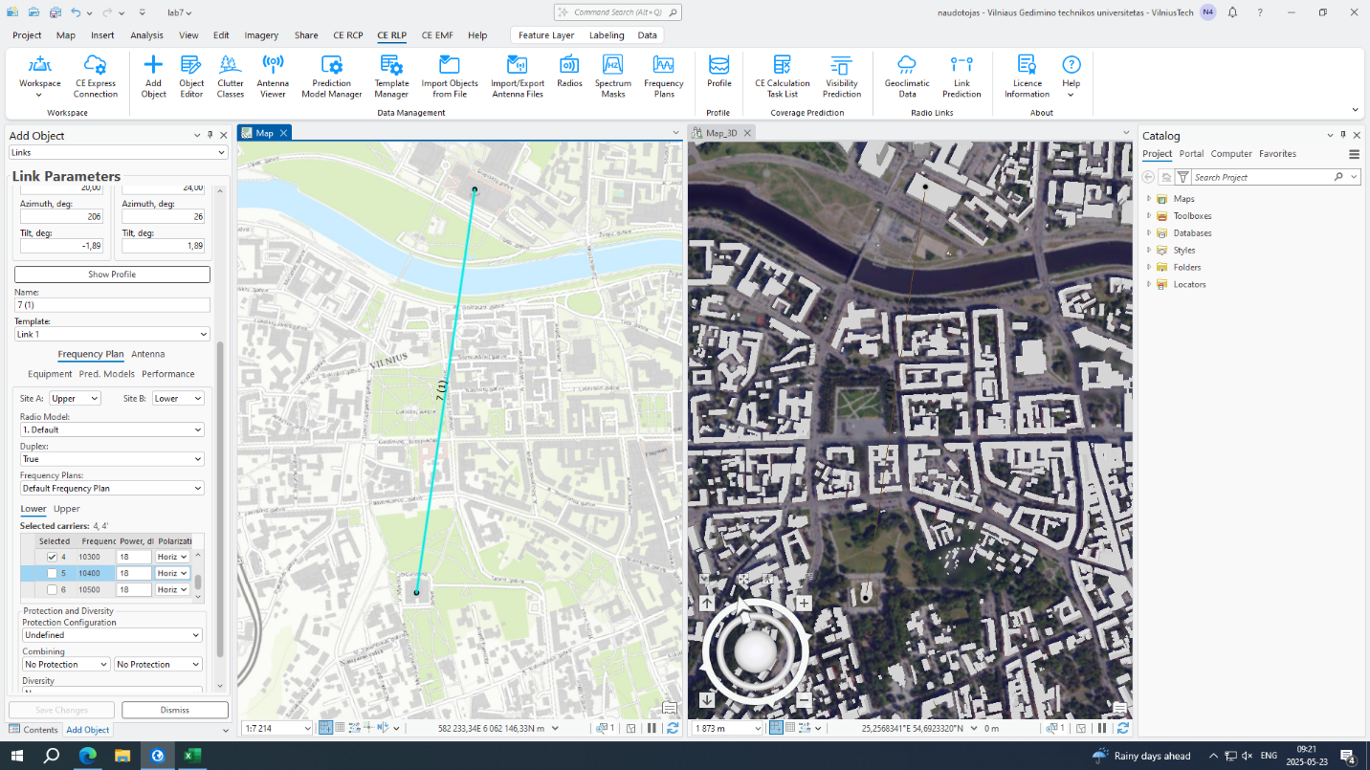 Section 4: Antenna Position and Height Adjustment

**Steps:**

* Modify antenna heights at both endpoints
* Reposition antennas if necessary to improve clearance
* Optimize antenna orientations for maximum signal strength
* Verify improved signal quality after adjustments
* Document final configuration parameters

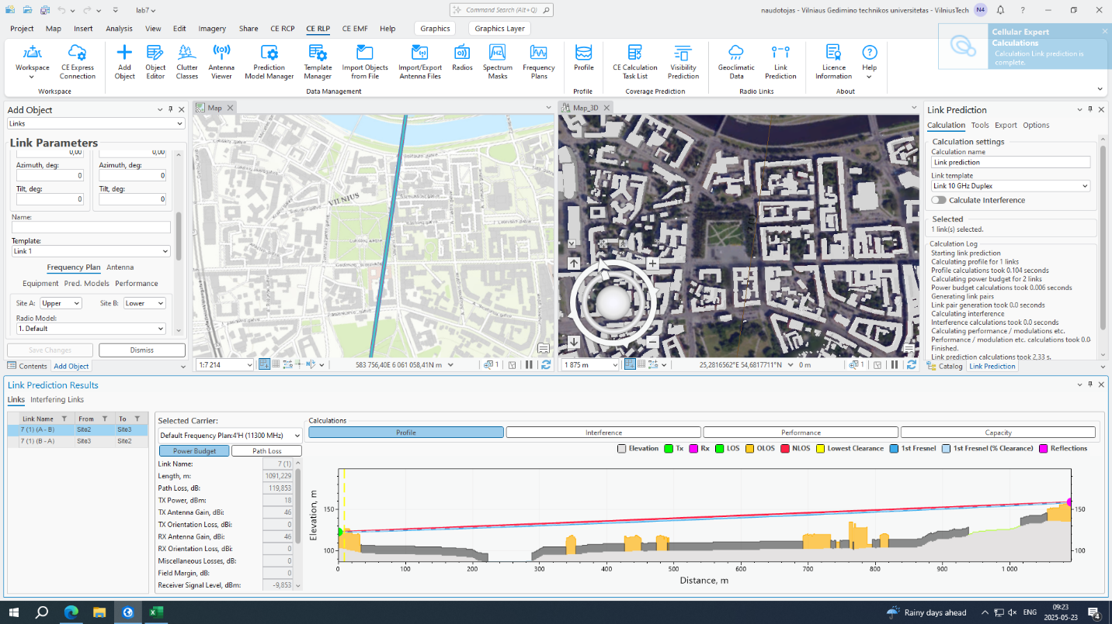 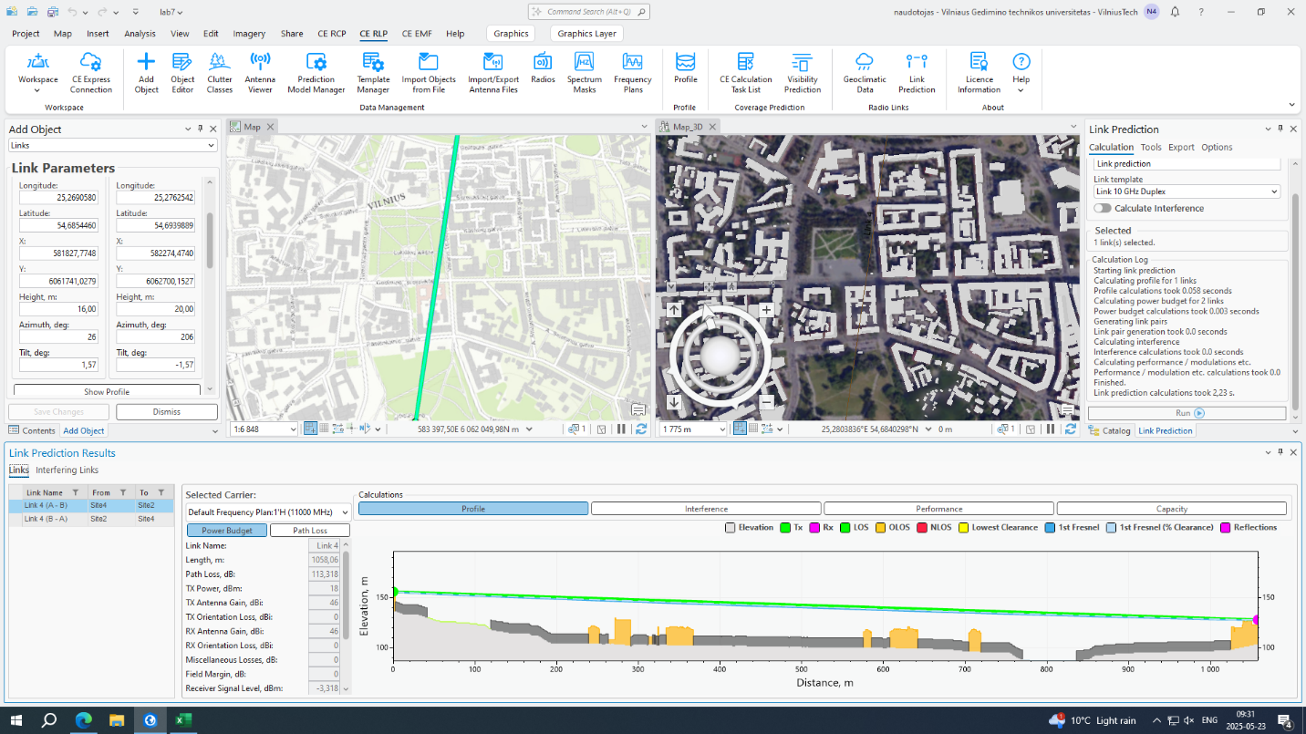

Theoretical Part

## Fresnel Zone Analysis

The Fresnel zone represents an ellipsoidal propagation region surrounding the direct radio path between transmitting and receiving antennas. This zone encompasses areas where electromagnetic waves undergo reflection and diffraction phenomena. Despite maintaining clear visual line-of-sight conditions, objects positioned within this zone can significantly impact signal integrity through interference mechanisms.

Optimal signal performance requires maintaining a minimum of 60% clearance of the first Fresnel zone from obstructions. The zone exhibits maximum width at the radio path's midpoint, tapering toward both antenna locations. Urban propagation environments present heightened challenges due to increased obstruction density from architectural structures and vegetation, resulting in elevated signal attenuation.

## Fade Margin Considerations

Fade margin constitutes the additional signal power allocation designed to compensate for unpredictable signal attenuation events. These variations stem from meteorological conditions, electromagnetic interference, multipath propagation effects, and physical obstruction dynamics. The margin ensures received signal levels remain above the minimum threshold required for reliable receiver operation.

Expressed in decibel units, fade margin requirements fluctuate based on environmental characteristics and propagation conditions. Metropolitan areas typically demand increased fade margin allocations due to elevated interference probability and signal degradation factors.

## Link Budget Analysis

Link budget calculations encompass comprehensive accounting of all signal gains and losses throughout the transmission path from source to destination. Key parameters include transmitted power levels, antenna gain characteristics, transmission line losses, free-space path loss, environmental attenuation factors, and fade margin allocations.

The fundamental objective involves ensuring adequate received signal strength for proper signal demodulation and data recovery. Dense urban environments frequently necessitate additional infrastructure considerations, including elevated antenna installations or intermediate repeater stations, to mitigate excessive signal degradation. Comprehensive link budget planning ensures consistent communication system performance.

# Conclusion

This laboratory exercise emphasized radiocommunication network planning utilizing Cellular Expert software integrated with Geographic Information System data. A high-capacity microwave communication link was established between designated locations, requiring comprehensive analysis of topographical features, obstruction profiles, and line-of-sight propagation conditions.

To circumvent signal blockage from forested terrain elevation, an intermediate relay station positioned on existing television broadcast infrastructure was implemented, demonstrating the critical importance of Fresnel zone clearance calculations. Students gained practical experience in endpoint configuration, antenna height optimization, link budget analysis, and performance verification through simulation modeling.

Results demonstrated that reliable communication links are achievable through strategic planning methodologies. However, certain scenarios may present cost-effectiveness challenges in meeting stringent fade margin specifications, transforming technical requirements into budget optimization considerations rather than purely engineering constraints.